10-12-2026, 10-13-2026

Project FIRE: updating the fire record and comparing it to the old
This reports details how the fire record was updated so it covers from 1996 to 2025. It compares this updated fire record to the older record spanning 1996 to 2010 so that we know we can trust it. The main question we are asking is: if we switch to an updated data set, will our results agree with our previous work? This is particularly important because we have four or more papers published using the older data set.
The project that organizes this work is called FIRE.
Data and data processing: Here I describe the older data set and then the new process to created an updated data set.
The old data was created for an old report: Tasks 1 - 7 v1.4 (final report) for a project assigned in 2005. It has obviously since then been updated several times to give data going up to 2010. The exact way this was done is not detailed here as it is complicated and how it was made is not important for this discussion.
In FIRE, the old master data set is stored in: data/raw/fire/2010_fire_data/old_fire_data.csv. It has one row per day with fire, giving area burned (ha) and number of fires for prescribed, ordnance, and lightning fires. It was compiled at some point from two SAS files (prescribedfires.sas7bdat and wildfires.sas7bdat); I checked, and the area totals in the CSV match the SAS files exactly. The record runs from October 1996 to September 2009. Unknown fires were processed as detailed in the older report.
To create the new data set, I gathered recent data from the APAFR (with help from Soe Min Thu) and wrote a script (process_fire_data.py) to make a new updated “master” data set. This script uses two shape files (APAFR_Burn_History_1977_2005.shp and APAFR_Burn_Histroy_2006_2026.shp) as its main information source. This process can be ported over to over projects (and in fact has been ported over to the MWB project). The updated master data set is stored in: data/processed/fire/fire_data.gpkg. It has one row per fire event from 1996 to 2025 and details the ignition sources as prescribed, military, and lightning.
Central to how well this data represents the true fire activity on the base is how we decide to handle unknown fires. I made a number of decisions:
(1) The new data had a significant issue in that the source files did not detail wildfire ignition source (either lightning or military) from 2006 to 2011. We did, however, find a set of older yearly shapefiles from 2006 to 2009 which did detail ignition source, and so we are we able to update our data for these years. This left 2010 and 2011, however, without ignition source data.
(2) The remaining unknowns were labeled using predictions from a logistic regression model. This model was not super accurate, but it was accurate enough that only some 800 hectares were at risk of being mislabeled (particularly for lightning fires).
(3) Many fires were labeled as “jump.” We assigned these fires an ignition source based on what type of fire burned close by on the same day or the day before the “jump” fire. One large “jump” fire was particularly important and was specifically handled by studying the data; it was called a “fenceline” fire that neighbored a wildfire but which was, in fact, a prescribed fire.

Comparing the old and new records: I compared the old and new records in terms of area burned. Here is a table describing how this breaks down per ignition source:
old_ha new_ha diff_ha diff_pct
Prescribed 125448 128814 3366 2.7
Military 18122 19408 1286 7.1
Lightning 6767 6666 -101 -1.5
Total 150336 154888 4551 3.0
Overall, the new data has 3.0% more area burned than the old, with military fire being the largest change.
Broken down by fiscal year, most years agree to within about 130 ha in every category. The differences are concentrated:
- Prescribed: FY1999 (+1,057 ha), FY2006 (+987 ha), and FY2008 (+642 ha) account for about 80% of the prescribed difference.
- Military: nearly identical through FY2005, then it swings back and forth from FY2006 to FY2009 (−80, +806, −456, +677 ha).
- Lightning: nearly identical except FY2009 (−270 ha).
I also provide a graph detailing the breakdown per month.

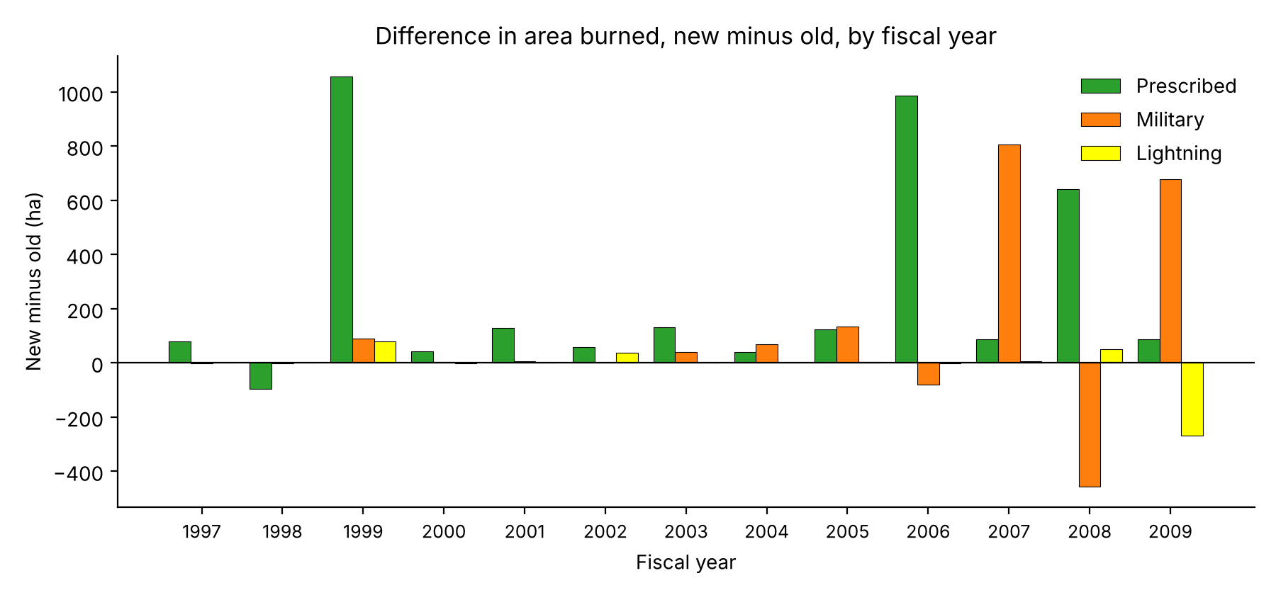
Difference by FY (new - old, ha)
FY Prescribed Military Lightning
1997 79 -1 -0
1998 -95 -1 -0
1999 1057 89 79
2000 42 3 -1
2001 128 7 -0
2002 59 -0 36
2003 131 41 -0
2004 40 68 -0
2005 123 133 2
2006 987 -80 -1
2007 88 806 7
2008 642 -456 49
2009 86 677 -270
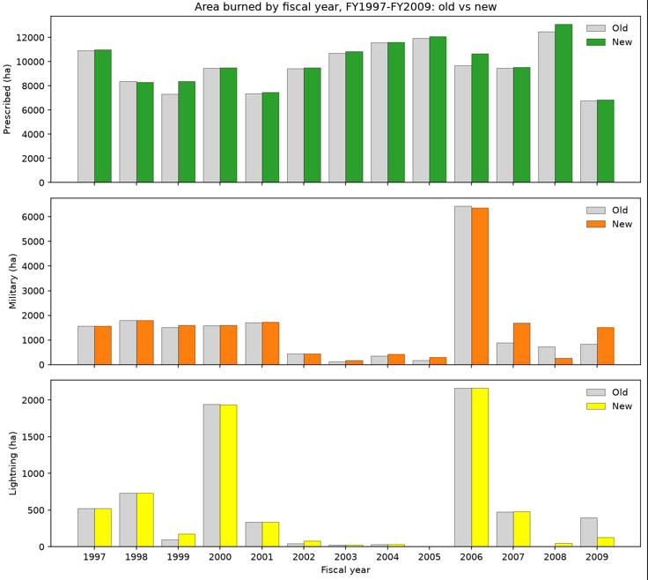
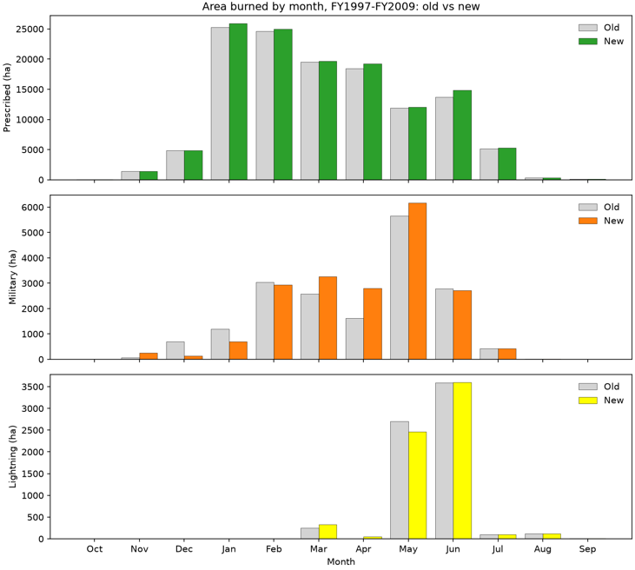
The main reason for the differences appears to be in how the old and new data processes handled unknown fires.
Conclusions: Our main concern is, is the new processing of the latest data of good quality? Because we know that the old data was processed with a high degree of diligence (we did, after all, publish a number of papers using it), if the new data agrees with it, that means we can have confidence in the new data.
I found that the new data agrees with the old data closely. Over FY1997–FY2009, the new data agrees with the old data within 3%.

